Sal f
Golden Valley High School
Wm. S. Hart Union High School District
“Home of the Grizzlies”
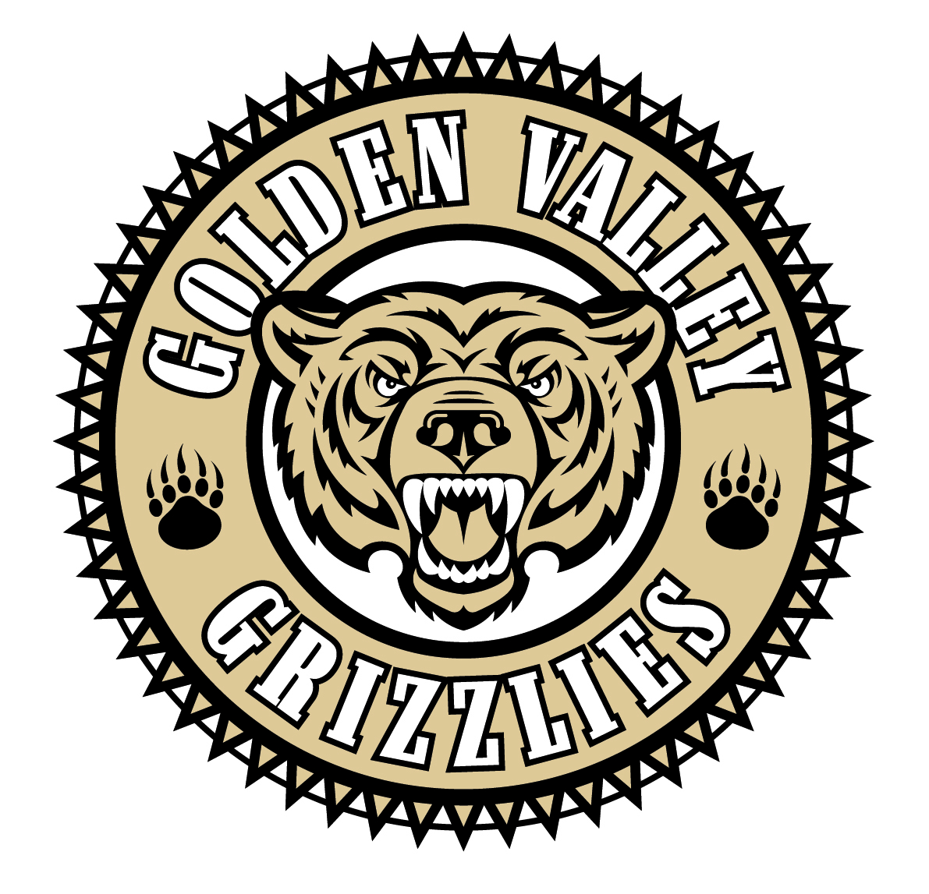
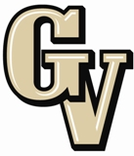

Parent Advisory Council (PAC) Meeting
February 24, 2014
6:30 PM

AGENDA

- PAC Meeting Welcome Sal Frias

- Secretary’s Report ACTION Jennifer Ryan

- Treasurer’s Report ACTION Emily Curtis

- President’s Report Sue Alterman

- District Advisory Council (DAC) Report Monica Camacho

- Parent Communications Council (PCC) Report Cherise Moore

- WASC Visit Sal Frias

- New Hart District Chief Financial Officer Erin Lillibridge

- Local Control Funding Update Erin Lillibridge

- School Safety Sal Frias

- ACSA Awards Carolyn Hoffman

Announcements: 2/25 - Choir Spaghetti Dinner - 5:30 pm
2/26 - ASB Food Fest - Lunch
3/1 - District Honor Band Concert at Hart High - 7:00 pm
3/11 - College Planning Experts Workshop - 6:30 pm
3/13 - Open House & Minimum Day
3/18 & 3/19 CAHSEE for all 10th graders and those needing retake
3/19 - Senior Meeting and Prom Fashion Show – 8:00 am
3/21 - Winter Color Guard Competition at GV
3/21 - End of 3rd Quarter
3/24 - PAC Officer Election Nominations

Next Meeting: March 24, 2014

The mission of GVHS is to provide a quality education to a diverse student population, develop each student’s maximum potential, and prepare students for success in the global community.

